**Table of contents:**

1. Introduction ………………………………………………………………………………………….………… P3
2. Detailed Steps and Descriptions in Design Thinking ……………….…………………….……….. P3-8

* Empathy Phase …………………………………………………………………………………….……. P3-4
* Define Phase ……………………………………………………………………………………………... P4-5
* Ideate Phase ……………………………………………………………………………………………….P6-7
* Prototype Phase ……………………………………………………………………………..………….. P7-8
* Test Phase ………………………………………………………….……………………………………… P8-9

1. Detailed Descriptions Include Problem, Solution, and Team Working ……….…………… P9-10
2. Design Thinking Assessment Points ..……………………………………………………………. P11-P12
3. Reflections ……………………………………………………………………………………………..…. P12-P13
4. Task for Each Member ……………………………………………………………………………………..…P13
5. Conclusion ……………………………………………………………………………………………………...P13

Design Thinking Process Report for Museum AR App

**Introduction:**

Welcome to our design thinking journey, where we share the story of creating the Augmented Reality (AR) Museum App. Born from our commitment to transforming the museum experience, our project tackles the dullness and confusion often faced during museum visits with traditional tools. This report guides you through our design thinking adventure – from recognizing challenges in traditional tools to developing a cutting-edge AR solution. Focused on engaging visitors, enhancing understanding, and providing smooth navigation, our journey includes stages like identifying problems, brainstorming ideas, developing the AR prototype, and refining it based on user feedback. The AR Museum App isn't just a fix; it's a vision. We aim to redefine how people interact with and enjoy museums, turning a regular visit into a dynamic, engaging, and enlightening exploration. Join us as we unveil the intricacies of our design thinking process, showcasing a creation set to revolutionize the conventional museum visit.

**Detailed Steps and Descriptions in Design Thinking:**

**Empathy Phase:**

At this stage, our team conducted an insightful interview with Nourerdin Mamdouh to gain a comprehensive understanding of the challenges faced by museum visitors, including issues around engagement, comprehension, and navigation. Nouredin's experience provided valuable evidence and revealed common problems such as exhibition boredom and difficulty in understanding. This phase has been ongoing since we received our first instructions from our lecturer, with the idea proposal initiated on 6 Nov, the submission of the project proposal on 15 Nov, and obtaining our first approval from our lecturer on 12 Dec. As we worked through the extended empathy phase, the team identified these challenges and made progress in empathizing with users' expectations during museum visits. The focus of the brainstorming session was to propose effective solutions that lead to the conceptualization of innovative AR applications. This application aims to prevent boredom, improve understanding, overcome navigation problems, and enhance the overall museum experience for visitors. In summary, the empathy phase served as the basis for our project, guided by Noreldin's findings. The proposed AR application turned out to be a promising solution for Noreldin and people with similar challenges to make museum visits more engaging, informative, and enjoyable.

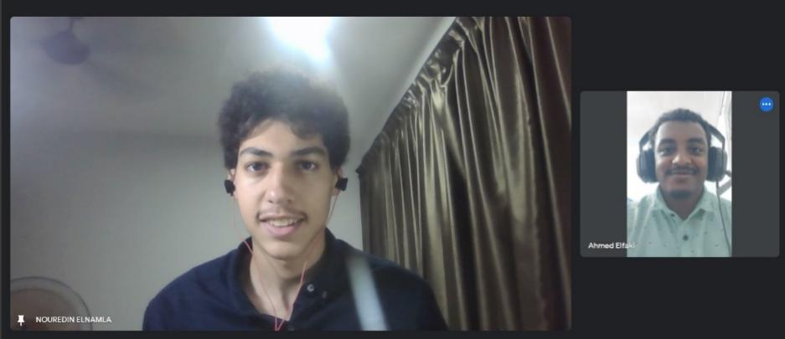

**Define Phase:**

At this stage, we conducted a survey to collect valuable data from museum visitors. As a result, we found a clear interest in improving the overall museum experience. The majority of respondents were open to technology, especially augmented reality (AR). Integration of AR applications is a promising way to improve visitor comfort and engagement, as a significant proportion of respondents are familiar with her AR and prefer to explore exhibitions at their own pace. I understand this. The potential of AR lies in its ability to fill the perceived gaps in the current museum experience and transform it into a more interactive and enjoyable engagement for diverse audiences.

Additionally, on 13 Dec, we interviewed Norfarhawa binti Khairy from Pengurus Galeri UTM for insights, gaining further understanding of the need to modernize technology in galleries. Her findings emphasized the importance of incorporating user-friendly elements such as video graphics, games, and QR codes to significantly improve visitor understanding of gallery content. She highlighted the importance of making technology safe and interesting and suggested introducing a gaming segment to attract younger generations.

On 15 Dec, we conducted a survey among students to gather input for the app, and by 23 Dec, we completed the survey and phase 2 of the design thinking process. As a result, the definition phase not only revealed certain challenges such as repetition and difficulty in understanding but also provided a clear direction for the project. The team now has a clear mandate to modernize technology, improve visitor understanding, and explore initiatives such as AR applications and gaming spaces to attract and engage younger audiences.

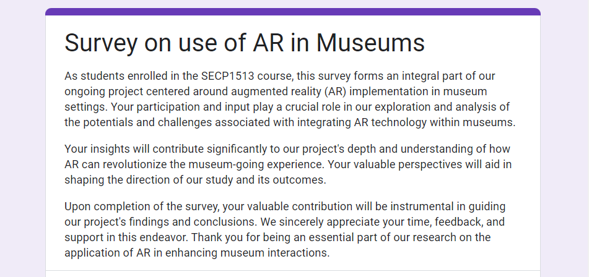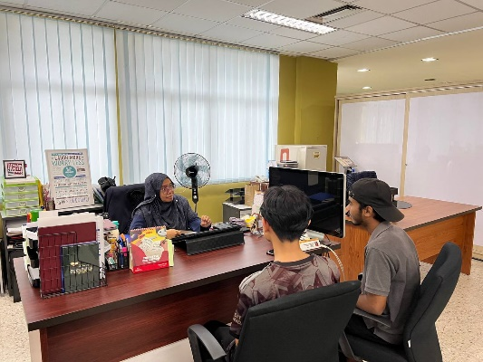

**Ideate Phase:**

In the "Ideate Phase," our team gathered to think up creative solutions for the challenges we found in our survey. We had a group discussion where everyone shared different ideas to make the museum experience better.

Realizing we needed new and exciting features, we looked for solutions to fix the problems we found in the survey. Norfarhawa binti Khairi, the leader of the graphic team at UTM gallery, told us it's essential to make the museum visit more fun. So, our team suggested adding a fun quiz section. This not only makes the visit enjoyable but also lets visitors compete, making the end of their museum exploration engaging and rewarding.

Knowing that navigating the museum was a big concern, some team members came up with ideas to make it easier for visitors to find the sections they like. As a result, we introduced two important features:

1. Nearby Feature: This makes it simpler for visitors to find exhibits and interesting places close by.
2. Contents of the Current Floor: This feature gives detailed information about the exhibits on the current floor, making it easier for visitors to explore.

Our idea process was dynamic, promoting creativity and different concepts. We finished our ideas and picked the best ones by voting until December 26. The quiz section and navigation features show our dedication to solving the challenges we found and creating a museum experience that's not just informative but also enjoyable and easy for everyone.

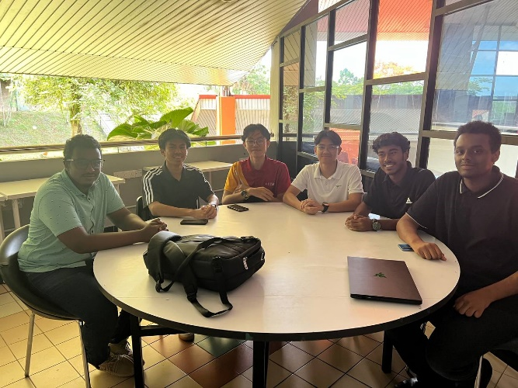 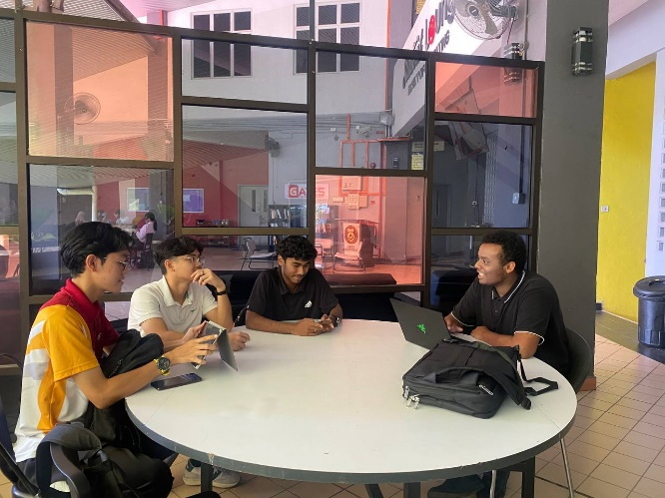

**Prototype Phase:**

In the Prototype Phase, our team worked on turning our idea into a cool and easy-to-use museum app. First, we made a detailed plan called Software Requirements Specification (SRS). This plan covered everything our app should do, like the pages and designs, to make it easy for everyone to use.

At first, we thought of using Canva for the designs, but later we found Figma.com, which was even better. One team member used Figma to turn our ideas into real designs. But then we found out we needed to write down our designs by hand. So, we quickly changed our digital designs into handwritten ones.

Next, we had to figure out how to show our prototype to our teacher. After some research, we decided to be creative and present the prototype like a cartoon phone. This made our presentation more fun and interesting.

When we moved between pages, we thought of different ideas. The best one was to make the pages move smoothly upwards, like sliding up to show the next one. This not only made the transition smooth but also added a nice touch to how the app feels.

We showed our first prototype to our teacher on 4 Jan, and we got some helpful feedback. Our teacher liked what we did but suggested a few improvements. The main thing was to make the prototype bigger so everyone in the class could see it clearly. So, from 4 Jan to 10 Jan, we made the changes and made sure all the details were easy to see.

We confidently presented the final prototype to our class on 11 Jan. This whole process, from making plans to digital and handwritten designs, and our creative presentation, ended with a prototype that not only fixed the initial problems but also got positive reactions from both our teacher and classmates.

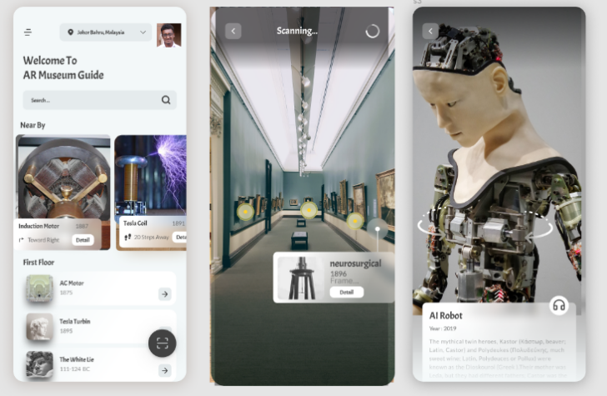 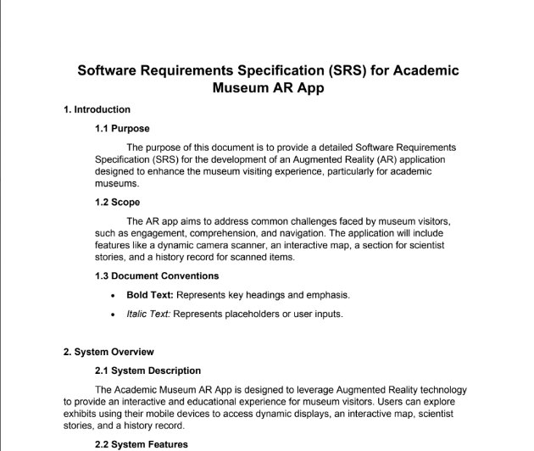

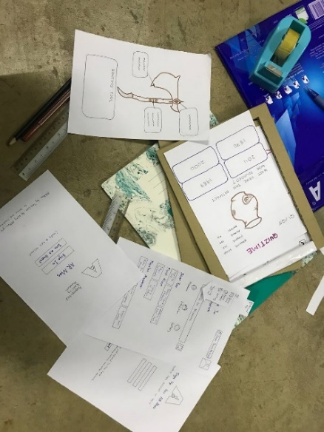 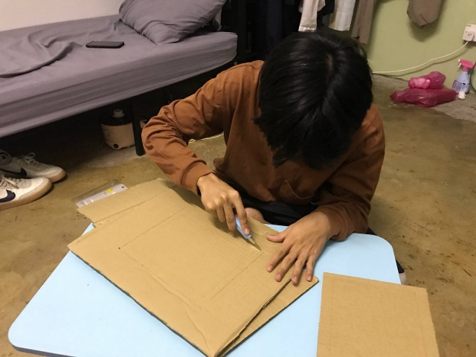

**Test Phase:**

In the Test Phase, our team took a proactive approach to gather valuable insights by presenting the app prototype to students and potential museum visitors. We aimed to observe how the app could aid and guide users throughout their museum journey.

During these sessions, we provided thorough explanations about the app's functionalities, encouraging participants to explore and provide feedback. The response was overwhelmingly positive. Users expressed how the app could significantly enhance their museum experience, underscoring its potential benefits for all museum visitors.

Notably, some students offered insightful suggestions to make the app even more user-friendly. One suggestion involved optimizing the home page by displaying essential information and avoiding information overload. This feedback prompted us to refine the app's design, ensuring that the home screen provided a clear and concise overview.

Another notable recommendation was the introduction of a coding assistant to guide users on how to effectively navigate and utilize the app. This insightful input influenced our development process, leading us to consider incorporating a tutorial or assistance feature for a smoother user onboarding experience.

Moreover, participants sparked innovative business ideas related to the app. One compelling suggestion involved introducing subscription plans for frequent museum visitors. The concept was to offer a demo visit of a museum as part of a subscription plan, catering to users who visit museums regularly and may appreciate a more flexible and cost-effective approach.

The positive feedback and constructive suggestions received during the testing phase not only validated the app's potential but also provided valuable insights for further refinement. As we move forward, we are eager to incorporate these enhancements and ensure that our app not only meets but exceeds the expectations of its users.

**Detailed Descriptions Include Problem, Solution, and Team Working:**

**Problem:**

Museum visitors often face challenges when using traditional tools such as maps, guidebooks, and museum labels. These issues represent the concerns of many museum visitors. Issues include repetitive exhibit content, difficulty understanding certain information, reliance on guides for assistance, and challenges associated with navigating and accessing information using traditional tools. These challenges do not just affect one particular visitor but are pervasive across museum visitors.

**Solution:**

To tackle the common challenges faced by museum visitors, we suggest the creation of an Augmented Reality (AR) prototype tailored for academic museums. This AR application is designed to revolutionize the visitor experience by providing an interactive platform that goes beyond the constraints of static exhibits. Users can utilize their mobile devices to scan exhibits, activating dynamic displays of experiments accompanied by detailed explanations. The interactive interface goes a step further by allowing users to make choices, thereby deepening their understanding of the exhibits. Additionally, a dedicated section highlighting the scientists behind the inventions adds a narrative element to the experience. This comprehensive solution aims to enhance engagement, comprehension, and overall satisfaction for museum visitors, addressing the limitations associated with traditional tools.

**Team Working:**

|  |  |
| --- | --- |
| **Date** | Activity |
| 6 Nov | Project initiation, idea proposal, and market research. |
| **15 Nov** | Submission of the project proposal. |
| **12 Dec** | Initial approval obtained; started working on the prototype. |
| **13 Dec** | Interviewed Norfarhawa binti Khairi from Pengurus Galeri UTM for insights. |
| **15 Dec** | Conducted a survey among students to gather input for the app. |
| **23 Dec** | Completed survey and phase 2 of the design thinking process. |
| **23 Dec - 26 Dec** | Ideation phase - Collaborative brainstorming, selection, and voting for prototype ideas. |
| **26 Dec - 4 Jan** | Prototype Development - Collaborative ideation, selection, and voting for prototype ideas. |
|  | SRS and UI development by Ahmed Mohamed. |
|  | Prototype design by Izzat Fakhrullah, Muhammad Habibullah, Saiful Aqil, Rami Yassein, and Ammar Husainy. |
| **4 Jan** | Presented the prototype to Dr. for approval. |
| **4 Jan - 10 Jan** | Edited the prototype based on Dr.'s feedback. |

**4.** **Design Thinking Assessment Points:**

**During the end of the project demonstration:**

1. Problem Identification:

* Description: Museum visitors commonly face challenges using traditional tools like maps, guidebooks, and museum labels, leading to repetitive content, comprehension difficulties, reliance on guides, and navigation issues.
* Evidence: We gathered insights through interviews, surveys, and research, establishing the widespread nature of these challenges across various museum visitors.

2. Solution Definition:

* Description: Proposing an Augmented Reality (AR) prototype for academic museums to address the identified challenges.
* Evidence: Detailed solution provided, including the AR application's features such as dynamic displays, interactive choices, and a narrative element highlighting scientists, aiming to enhance engagement and comprehension.

3. Alignment with Problem:

* Description: Checked the prototype against the identified problems to ensure it effectively addresses the challenges faced by museum visitors.
* Evidence: The AR prototype demonstrates a clear alignment with the identified issues, offering dynamic displays, interactive features, and narrative elements to overcome the problems associated with traditional tools.

4. User Testing:

* Description: Conducted tests with students to gather feedback on the prototype's usability and effectiveness.
* Evidence: Students were involved in testing the AR prototype, providing valuable insights into its performance, user-friendliness, and the extent to which it solves the identified challenges.

5. Iterative Improvement:

* Description: Gathered feedback from both team assessment and user testing to make iterative improvements to the prototype.
* Evidence: Prototyped adjusted based on Dr.'s feedback and further refined through editing to ensure the proposed solution is optimized and effective.

6. Overall Impact Assessment:

* Description: Assessed the overall impact of the AR prototype on solving museum visitors' challenges.
* Evidence: Collected feedback from team discussions, user testing, and improvements made, indicating that the prototype is well-positioned to address the identified problems and enhance the museum visitor experience.

7. Satisfaction and Engagement:

* Description: Explored how the AR prototype contributes to visitor satisfaction and engagement.
* Evidence: The interactive features, dynamic displays, and narrative elements were designed with the goal of increasing visitor satisfaction and engagement, aligning with the project's objectives.

8. User Reviews:

* Description: Collected reviews from students who tested the prototype, gauging their perceptions and experiences.
* Evidence: Student reviews provide firsthand accounts of the prototype's impact, usability, and effectiveness in addressing the challenges faced by museum visitors.

9. Future Considerations:

* Description: Discussed potential future considerations for refining and expanding the AR prototype.
* Evidence: Open dialogue within the team regarding potential improvements and future enhancements to ensure the prototype remains effective and relevant.

**5. Team Reflections :**

**Rami:**   
 It was a fun and engaging project to do and it helped with enhancing our ability to work as a group to come out with great result. it also helped me to understand more about the software development world and how we can make use of the technologies that have been developed recently like (AR)

**Habibullah:**

This project help me to work with a team as this team is a great team because we can come up with a great idea but for our level, we just generate the idea. However, I think this project could be a great service for the society and museum's administrator if this idea work out. During the process of this project, I realise that technology is keep developing as time goes by, so it helped me to discover more great technology in this era and maybe what to improve.

**Izzat:**   
 Nothing to say, this project was an absolutely golden experience for me as I was able to push myself to get out of my comfort zone. Throughout this journey, I started to believe in myself, i now started to get the confidence to talk and present in a crowd. This journey has enhanced my critical thinking, social skills, and much more as I needed to work in a team, brainstorm ideas, and implement the prototype of the project. Last but not least, this journey has helped me to understand AR technology better and increase my knowledge about the ICT world.

**Saiful:**

my personal opinion about this project is that I've learned a lot about how to manage and divide tasks in a group and how to work in a group. For the prototype, I feel like it is a good exposure for us as a computer science student to know it's not an easy thing to design a system such as an application. At the same time, we also learn from the research that we do from the website and people around us. Lastly, for the presentation part, I learn to be more confident in how to present things in front of people and will keep improving on it. my hope for this project is that we can bring this AR Gallery idea in the future and work on it to make it real.

**Ahmed:**

This project was an amazing experiment for me, where I learned how to think in more logical and systematic ways, How to propose ideas, and how I can test them before trying to make them.  
When we first thought about this idea and I was assigned to do the proposal, It was a challenge for me. I thought this idea would be very hard to implement and so on but when I really tried to search more about it, it seemed as easy as could be, but needed teamwork, So that is the second thing I learned, how to work with a team and deliver the best results that could ever exist.  
After we finished all the design thinking process phases and made it through every obstacle that we found, I learned a lot from all the mistakes we have been through, I am hoping that this project will come alive and will be used by every museum in this country and all over the world.

**Amar :**

Working on our group project was like a big learning adventure. We learned that talking to each other and understanding everyone's job is super important. Our team had different skills, and that made our project better because everyone had good ideas. Sometimes, it was hard to manage time, so we learned to plan better. We also found out that being flexible and able to change plans is really helpful when unexpected things happen. This project taught us that talking well, being open to different ideas, and being ready for changes are things we should always do when we work together.Overall I am truly happy with the outcome of the project and grateful to be a part of this project.

Working on our group project was like a big learning adventure. We learned that talking to each other and understanding everyone's job is super important. Our team had different skills, and that made our project better because everyone had good ideas. Sometimes, it was hard to manage time, so we learned to plan better. We also found out that being flexible and able to change plans is really helpful when unexpected things happen. Sharing helpful feedback was cool too – it helped us get better without feeling bad. This project taught us that talking well, being open to different ideas, and being ready for changes are things we should always do when we work together.窗体底端

**Task for Each Member:**

|  |  |
| --- | --- |
| **Task** | **Assign to** |
| **Proposal** | Izzat Fakhrullah  Ahmed Mohamed |
| **First Interview with a visitor** | Ahmed Mohamed |
| **Survey** | Rami Yassein  Ahmed Mohamed |
| **Interview with UTM gallery** | Muhammad Habibullah  Saiful Aqil  Ammar Husainy |
| **SRS and UI** | Ahmed Mohamed |
| **Prototype design** | Izzat Fakhrullah  Muhammad Habibullah  Saiful Aqil  Rami Yassein  Ammar Husainy |
| **Video** | Rami Yassein |
| **Report** | Ahmed Mohamed Khalid |

**Conclusion:**

The design thinking process played a crucial role in shaping our project, ensuring a user-centered approach and iterative refinement. Through a combination of empathy, definition, ideation, prototyping, and testing, we addressed the identified challenges and created a transformative AR museum app. The collaboration among team members and the reflective insights gained from the process contribute to the success and continuous improvement of our project.